GRAMMAR
Exercise 1
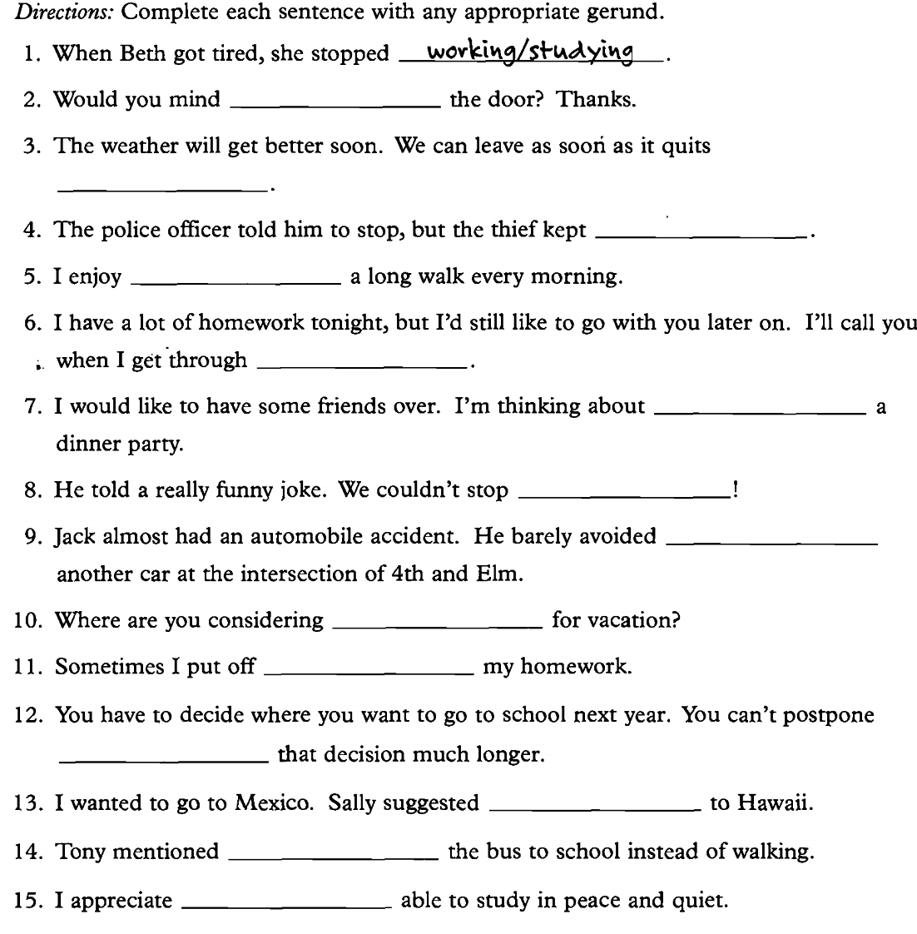
Exercise 2
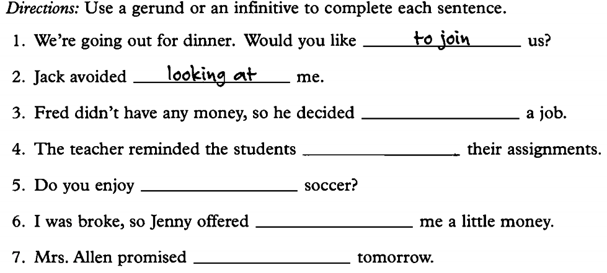
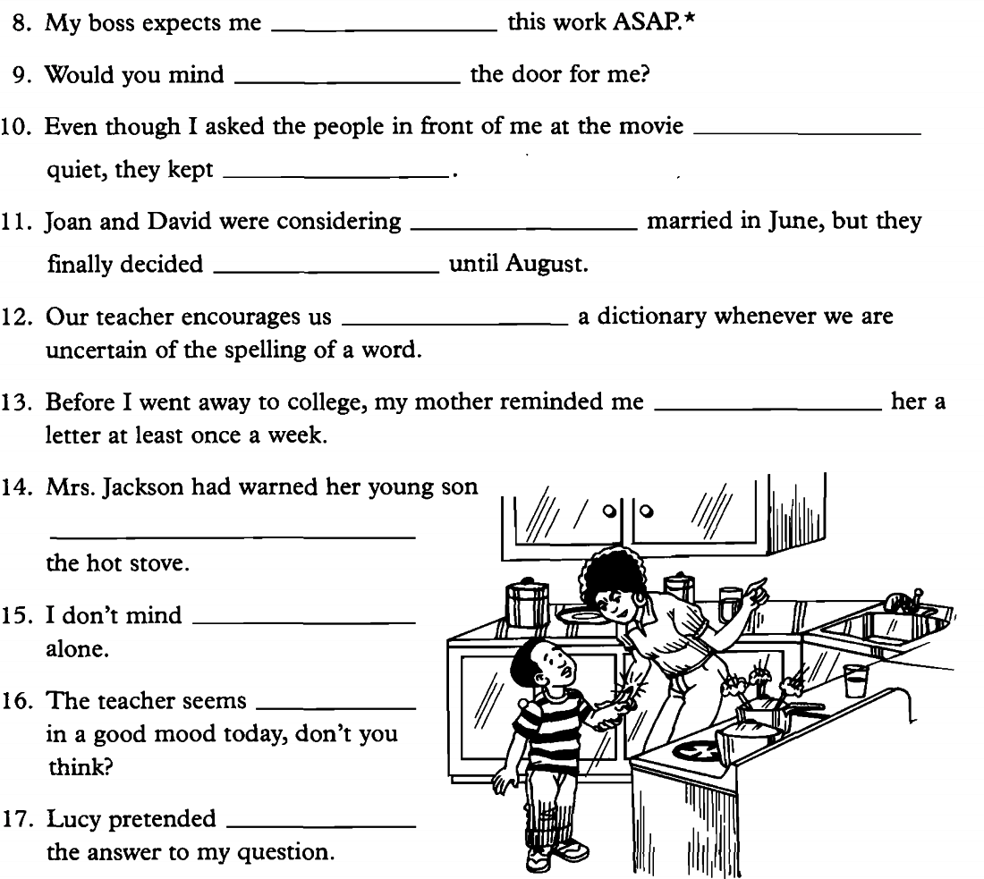
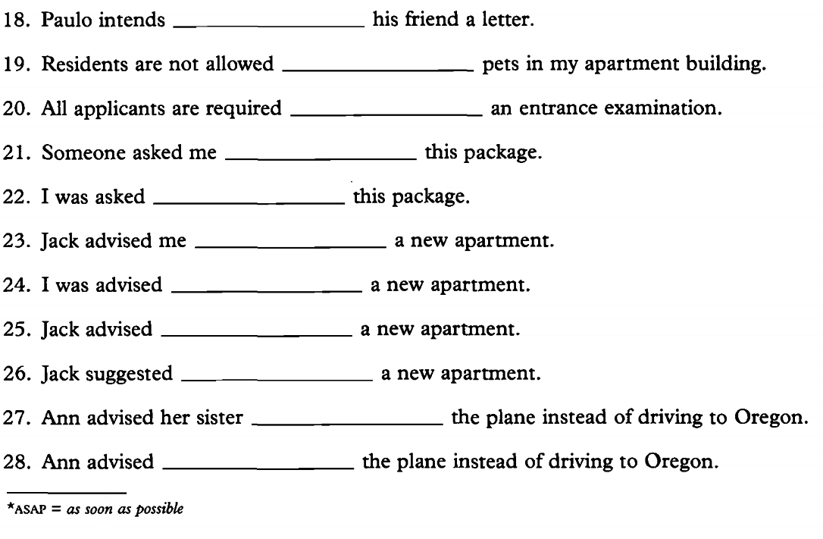
ANSWER KEYS
Exercise 1

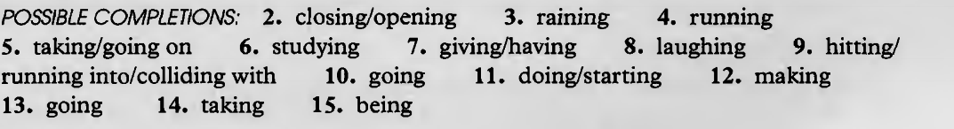

Exercise 2

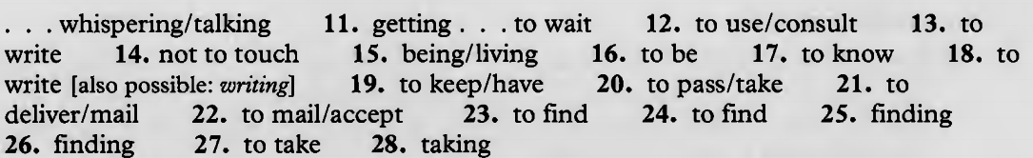

SOURCE:
Betty Schrampfer Azar (2002). Understanding and Using English Grammar. Pearson Longman.

